**EduHUB**

The " EduHUB" is a comprehensive program designed to test the knowledge and skills of university students in various subject areas. The project aims to assess students' understanding of key concepts and their ability to apply them to real-world scenarios, as well as to identify areas where students may need additional support.

The testing process will be conducted through a combination of written exams, online assessments, and practical assignments, which will be designed to measure students' knowledge, critical thinking skills, problem-solving abilities, and creativity. The project will cover a wide range of subject areas, including but not limited to mathematics, science, social sciences, and humanities.

In addition to assessing students' academic performance, the project will also provide valuable feedback to both students and faculty members. Students will receive detailed reports on their performance, highlighting their strengths and areas for improvement. Faculty members, on the other hand, will be able to use the data collected through the project to inform their teaching strategies and course design.

Ultimately, the "Student Testing Project" is intended to support the academic success of university students by providing them with meaningful feedback and identifying opportunities for growth and improvement. By promoting a culture of continuous learning and development, the project will help students to achieve their full potential and prepare them for success in their future careers.

**Roles :**

|  |  |
| --- | --- |
| Role | Description |
| Guest | A user that isn't logged in. Can sing up and log in |
| Student | Register in a system, log in/log out, choose a test, pass the test, view a list of tests, view past tests, view tests results, rate test. |
| Teacher | Register in a system, log in/log out, view a list of students who registered for their test, create a test,edit test, delete test, register students to their tests,view results. |
| Admin | Can view info about users. Edit teacher's tests, add teachers to the system, view results. |

**Testing Management System**

|  |  |  |  |  |
| --- | --- | --- | --- | --- |
| **N** | Role | Use case | Description | Action name |
| **1** | Student | View test | Can see the topic of a test, teachers name | Viewing Test |
| **2** | Take test | Can take the selected test | Pass Test |
| **3** | View results | Can see results of passing test | View results |
| **5** | Teacher | Create a test | Add a test to the system. | Add a test |
| **6** | Edit a test | Edit the topic, correct tests, change questions | Edit a test |
| **7** | Delete a test | Delete a test from the system | Delete a test |
| **8** | View students | View the list of students who added for a course. | View students |
| **9** | View students results | Can see how students pass the test | View results |

**Account Management System**

|  |  |  |  |  |
| --- | --- | --- | --- | --- |
| **N** | Role | Use case | Description | Action name |
| **1** | Teacher/student/admin | Log out | Log out of a system | Log out |
| **2** | Guest | Log in | Log in to a system | Login |
| **3** | Sign up | Sign up in a system | Register |

**User Management System**

|  |  |  |  |  |
| --- | --- | --- | --- | --- |
| **N** | Role | Use case | Description | Action name |
| **1** | Student/Teacher/Admin | Manage account | Edit personal information, delete an account, change a password. | Manage account |
| **2** | Admin | Add Teachet | Add teacher to the system | Add teacher |

**Use case diagrams**

**Guest role use case diagram**

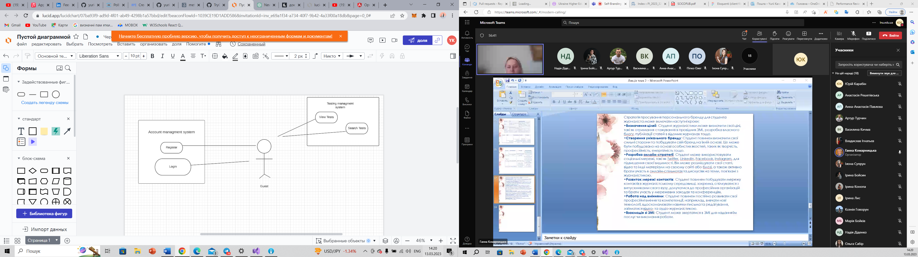

**Student role use case diagram:**

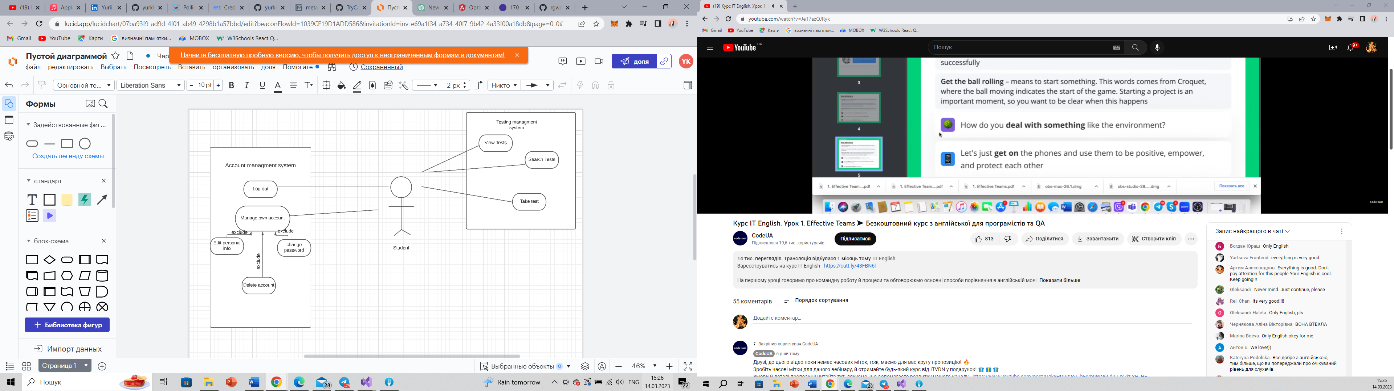

**Teacher role use case diagram:**

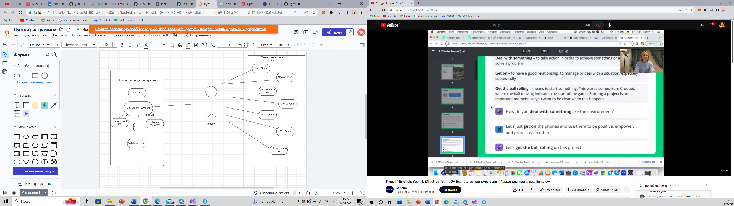

**Admin role use case diagram:**

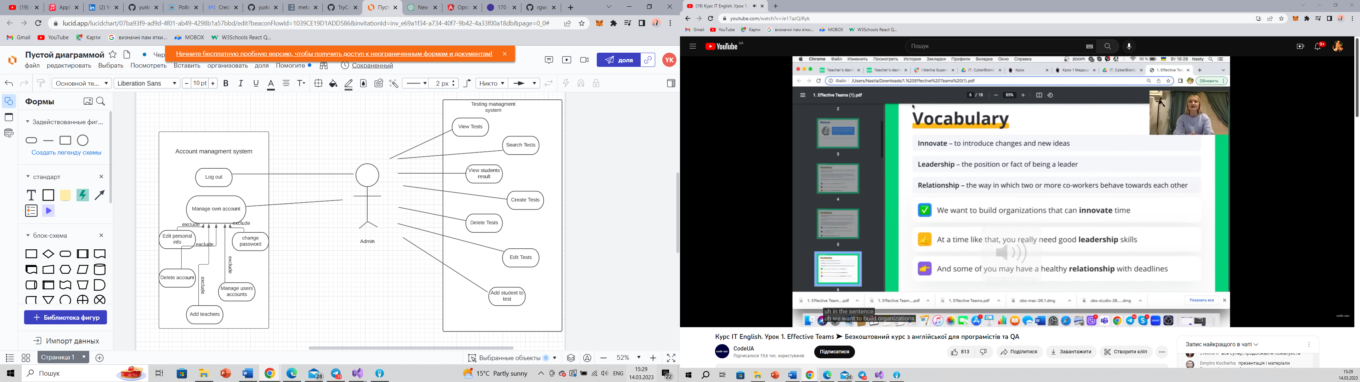

**Sequence diagram:**

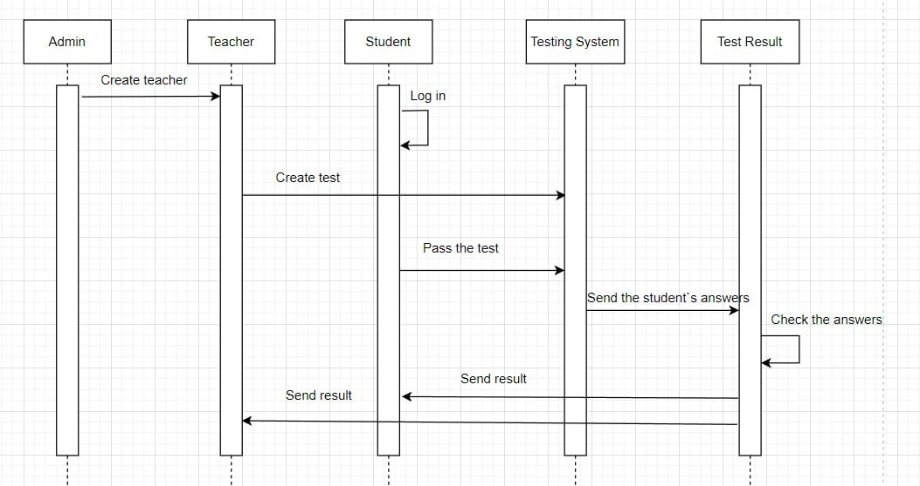

**ER-diagram:**

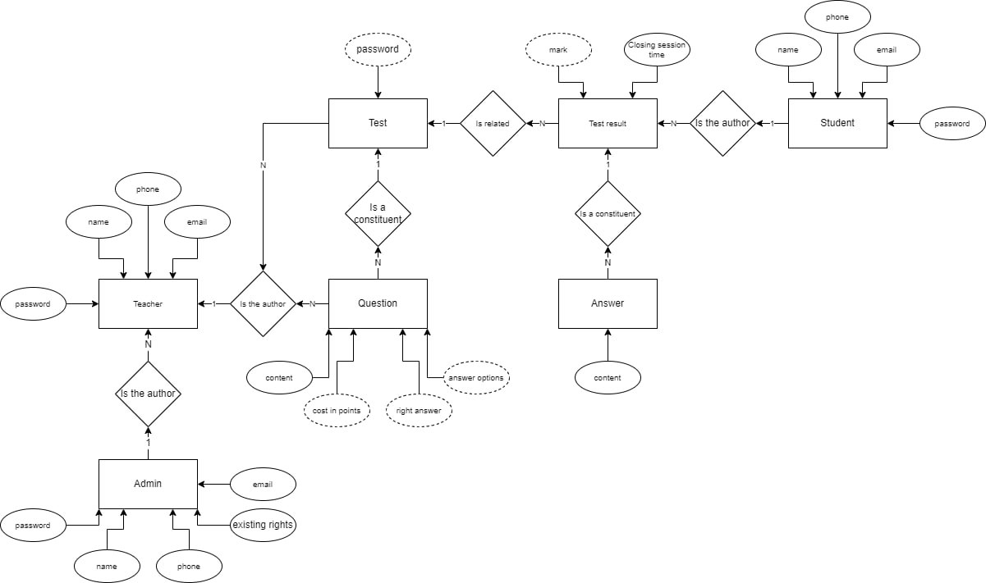

**MOCKUPS**

Register

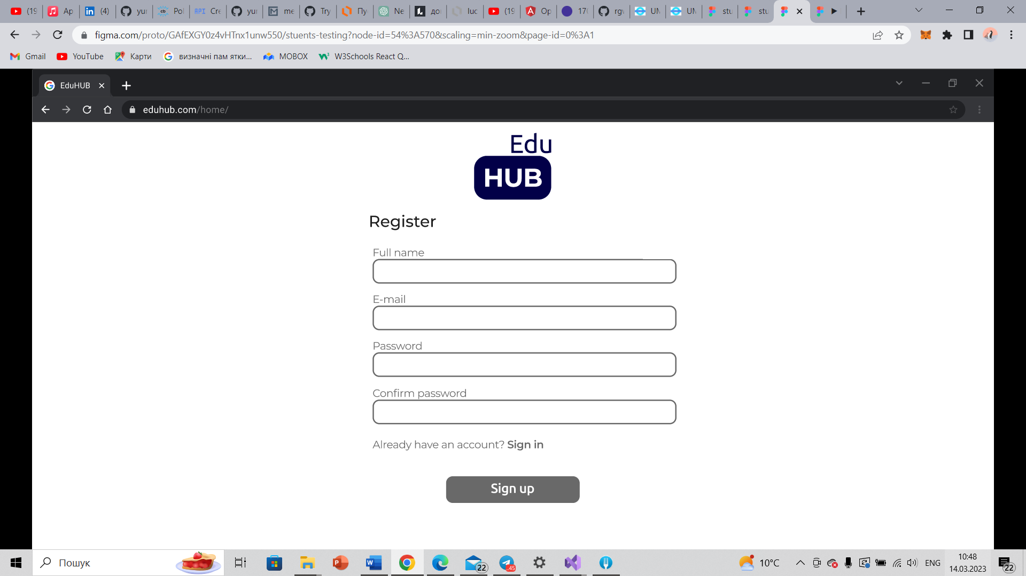

Login

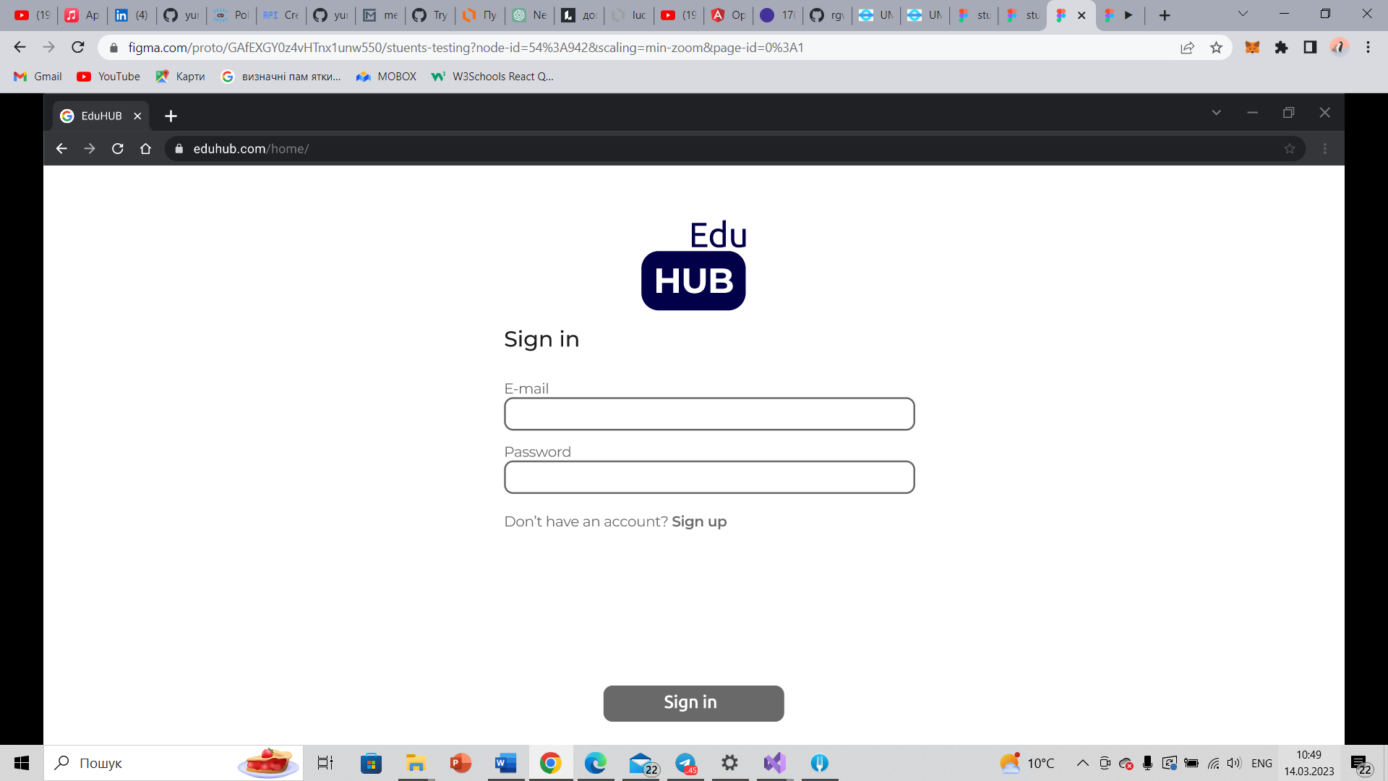

Students home page

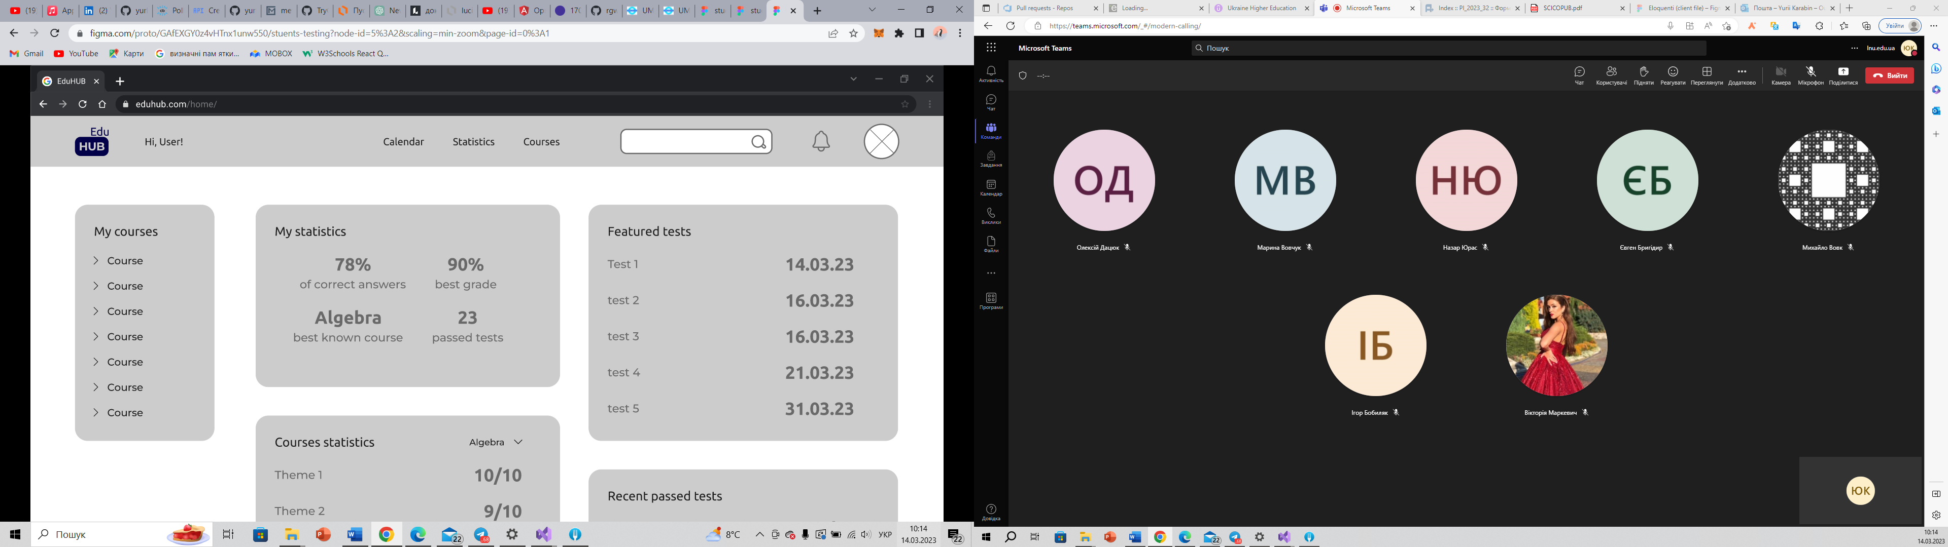

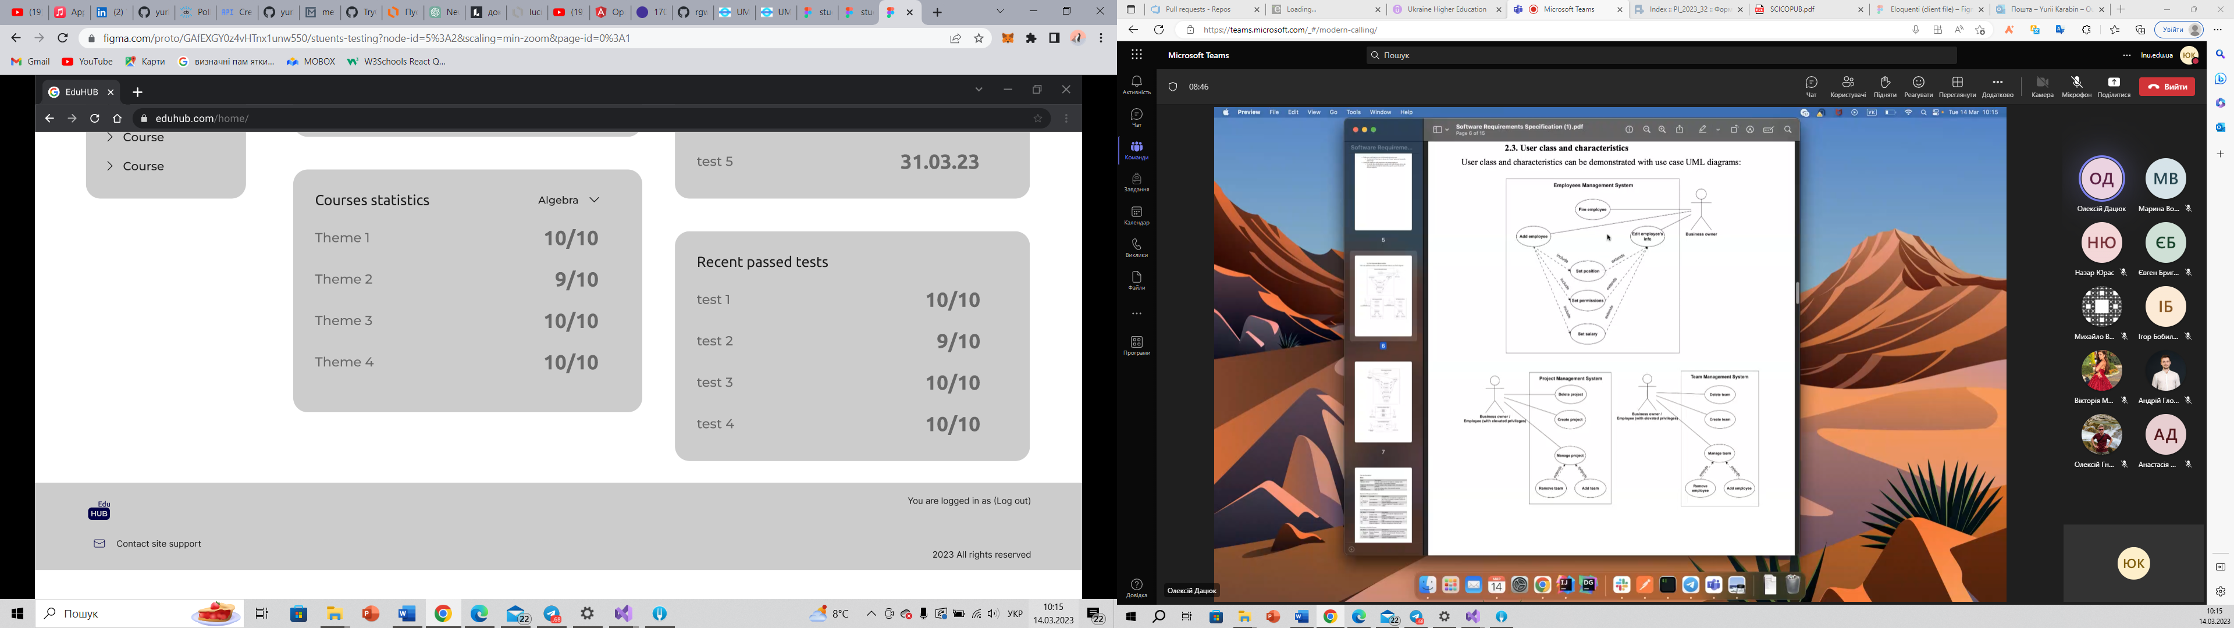

Course page

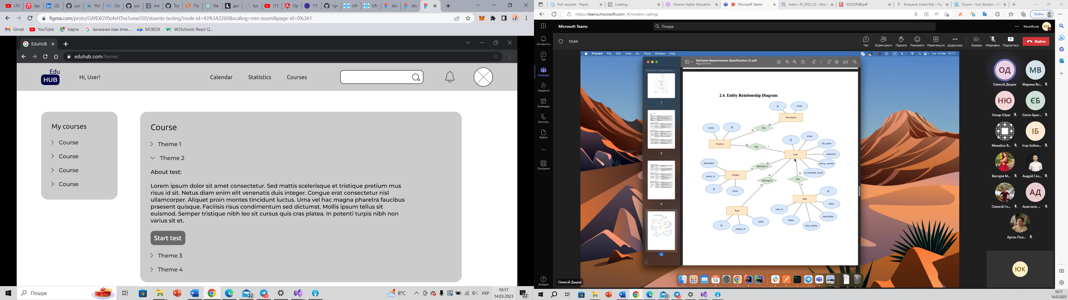

Teachers home page

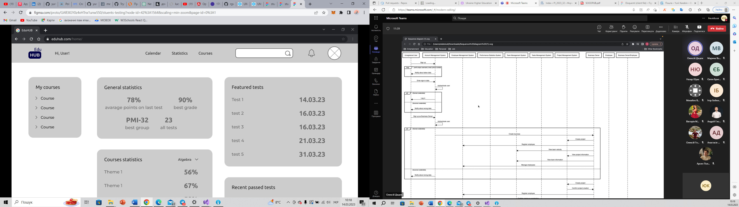

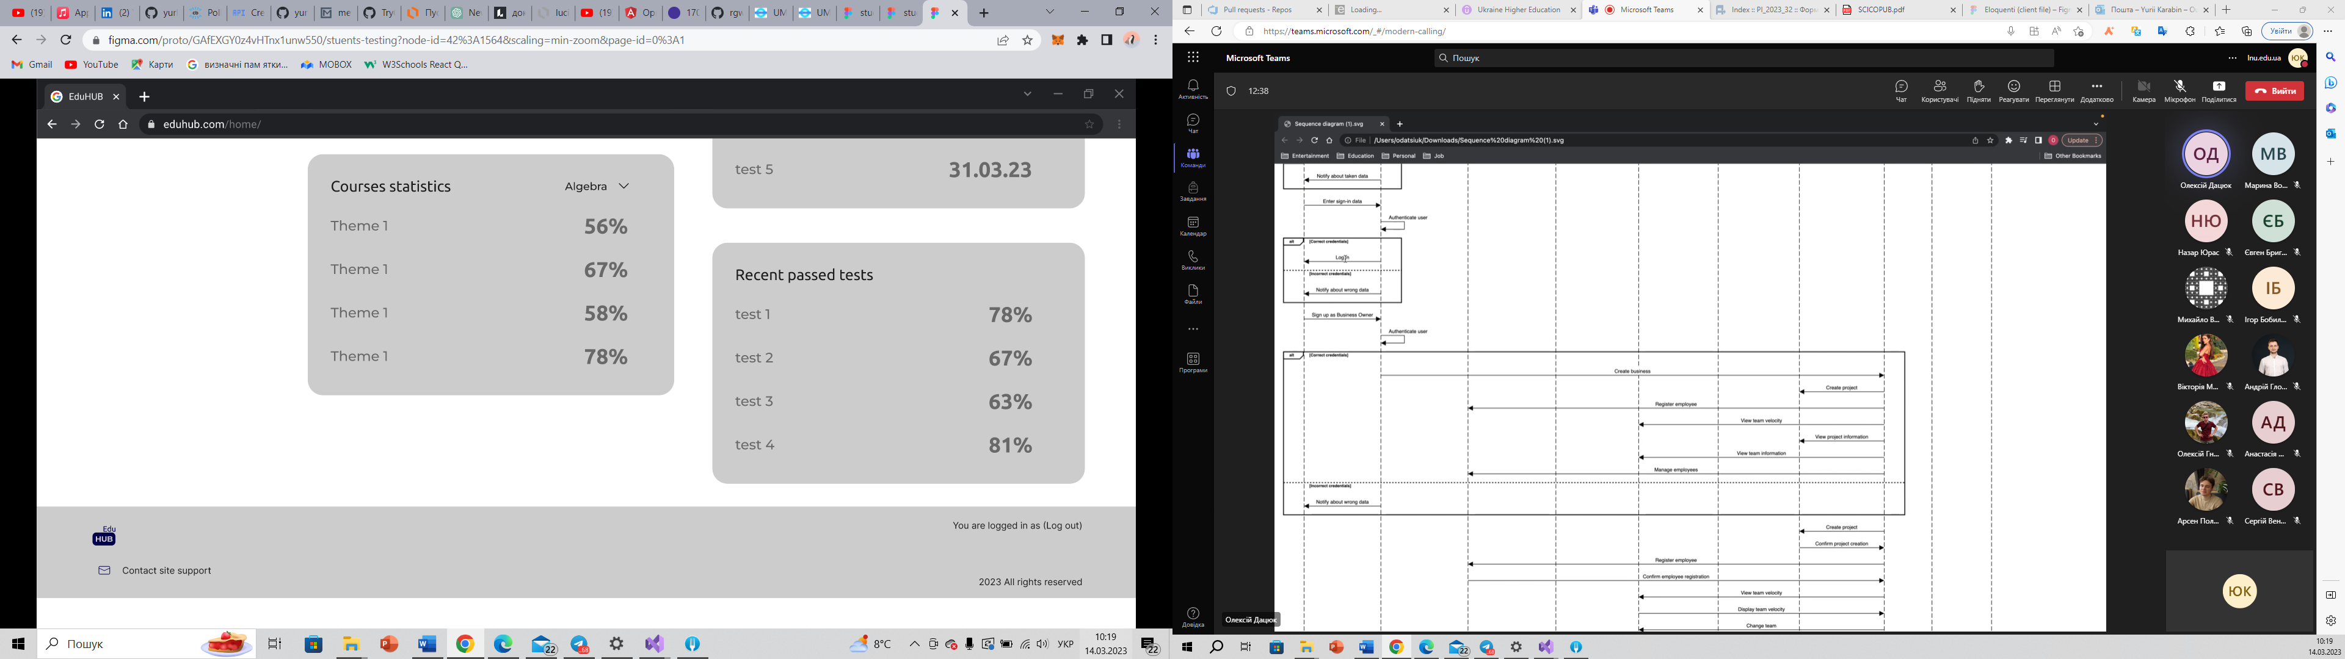

Test question page

